19 Inch

Online UPS

Technical Parameter

BWT-25003KSO ONLINE UPS

 |  | Index(VA) |  | BWT-25003KSO
 |  | Rated Input Voltage（Vdc） |  |  | 48V
DC INPUT |  | Rated Input Current （A） |  |  | 63A
 |  | DC Input Range (Vac) |  | 40-66V
 |  | Reflected Noise Current. |  |  | ≤10%
AC Bypass |  | Bypass Voltage Range （Vac） |  | 120V-270V(±10V)
Input | Rated Input Current（A) |  |  |  | 13.6A
 |  | Capacity（VA） |  |  | 3KVA
 |  | Rated output Capacity（W） |  | 2400W
 |  | Output Voltage and Frequency |  | 220Vac 50Hz/60Hz
 |  | Output Current（A） | 11.0
 |  | Voltage Accuracy（V） | 220±1.5%
 |  | Frequency Accuracy（Hz） |  | 50±0.1% or 60±0.1%
AC |  | Waveform |  | Pure Sine Wave
Output |  | THD |  | （ |  |  |  | ）
 |  |  |  | ≤3% line load
 |  | Dynamic Response Time |  | 5%(（load 0←→100%）
 |  | Power Factor（PF） | 0.9
 |  | Overload Capability | 105%-150% 10s |  |  |  |  | >150% 5s
 | Inverter efficiency（80% line load） |  |  |  | ≥93%
 |  | Line mode←→ Batt mode |  |  | 0ms
 |  | Line/Batt mode ←→ Bypass（ms） |  |  | ≤4ms
 |  | Dielectric Strength（Input & |  |  |  | ， | 1minutes
 |  | Output) |  | 1500Vac-10mA
working |  | No Load Power Consumption |  |  | ≤67W
environ |  | Ambient Temp. |  | 0℃~+55℃
ment
 |  | Humidity |  | 0~90%,No condensation
 |  | Altitude（m） |  |  | ≤2000
 |  | Charging current |  | Default: 10A, max: 60A
Charging |  | Floating Charging Voltage |  |  | 54Vdc
Mode |  | Overcharge Protection |  |  | 66Vdc
 |  | Charging Algorithm |  |  | 3 step
 |  | Reserved © Shenzhen Bwitt Power Co.ltd .Without Notice Once Technical Have Been Change
 |  | Web: www.bwitt.com.cn Tel: 86-15307200395

 | LCD Display |  | Input/output Voltage、Frequency、Output Current、Temp.、
Indicate |  |  | Capacity Rate .etc
 | Inverter Status |  | Off Grid Status、Inverter Status、Batter Under&Over Vol、
 |  |  | Output Over load
Dimension | （ | ） | 420*438*130.8mm
s | 19”Rack mount D×W×H
 | mm
Weight | Net weight(kg) |  | 15
 | Protection |  | Input under Voltage、Input over Voltage,Output Over load、
 |  |  | Short circuit

Function And Feature

- True sine wave output (T.H.D < 3%);

- Configurable input voltage range for home appliances and personal computers via LCD setting

- Configurable battery charging current based on applications via LCD setting

- Auto restart while AC is recovering

- RS232 and RS485, SNMP Optional communication Port;

- Smart battery charger design for optimized battery performance

- Cold start function

- Zero-transfer Time

Product Display
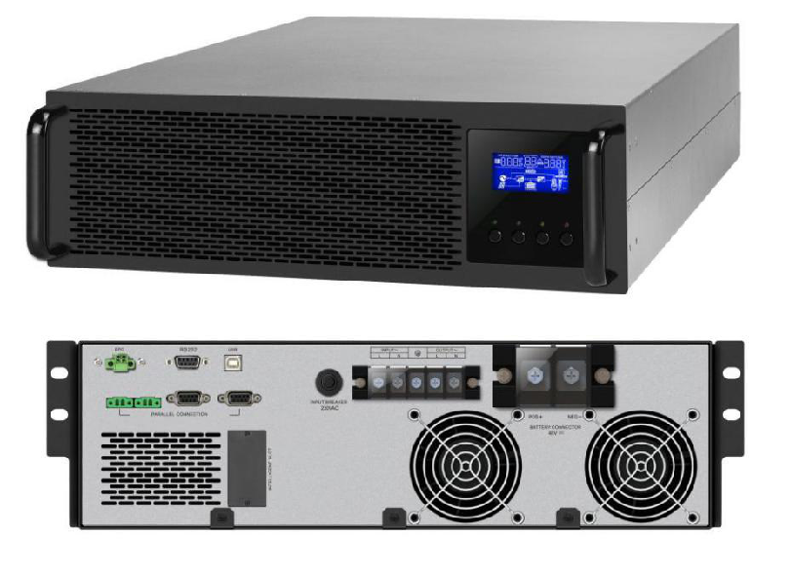

Reserved © Shenzhen Bwitt Power Co.ltd .Without Notice Once Technical Have Been Change

Web: www.bwitt.com.cn Tel: 86-15307200395

